Employee Relations in a Union-Free Environment
Many times, employee relations break down because of interpersonal conflicts. At work, for example, employees and supervisors disagree and cannot get past the issue.
The video below encourages employers to take a proactive approach to employee relations so that problems and issues do not escalate.
Source: TheMyHRpro. (2013, April 10). Employee and labour relations [Video file]. Retrieved from https://www.youtube.com/watch?v=EnMcAHsGZ2E

Read about successful employer practices taken by today’s organizations to maintain good employee relations.
What can we do as individuals, however, to handle disagreements at work? View the following video that provides you the simple STABEN model on how to work through disagreements amicably.
Source: Byrne, J. (2013, April 22). Conflict resolution in 6 simple easy steps [Video file]. Retrieved from https://www.youtube.com/watch?v=DSGy5yvC0hM
What Are Labor Relations?
There are times when the relationships between employers and employees break down and the employees feel they need help from a third party. This is when a labor union might appear attractive to employees in their attempts to try to improve workplace conditions. Read the article What Are Labor Relations? from wisegeek.org which begins our discussion of labor unions. (Make sure to review the key terms that follow the article.)
The Nature of Unions
A labor union, or union, is defined as workers banding together to meet common goals, such as better pay, benefits, or promotion rules. In the United States, 11.1 percent of American workers belong to a union, down from 20.1 percent in 1983 (See Bureau of Labor Statistics [Jan. 2016]. Union Members.)
We will discuss the history of unions, reasons for decline in union membership, union labor laws, and the process employees go through to form a union. First, however, we should discuss some of the reasons why people join unions.
People may feel their economic needs are not being met with their current wages and benefits and believe that a union can help them receive better economic prospects. Fairness in the workplace is another reason why people join unions. They may feel that scheduling, vacation time, transfers, and promotions are not given fairly and feel that a union can help eliminate some of the inequity associated with these processes. Let’s discuss some basic information about unions before we discuss the unionization process.

History and Organization of Unions
Labor Union AFL-CIO Perspective
The following video shows a history of labor unions from the perspective of the AFL-CIO:
Source: PAaflcio. (2011, January 11). A brief history of unions [Video file]. Retrieved from https://youtu.be/ubIWyT7nGdU

The first local unions in the United States were formed in the 19th century, eventually leading to the establishment of the National Labor Union (NLU) in 1866.
The goal of the NLU was to form a national labor federation that could lobby government for labor reforms on behalf of the labor organizations. The NLU pushed for the 8-hour workday, which was passed by Congress for government workers in 1868. However, inconsistent enforcement made the statute almost insignificant. Because of a focus on government reform rather than collective bargaining, the NLU collapsed in 1873, and many workers later joined the Knights of Labor.
The Knights of Labor grew as a labor union for coal miners, but also covered several other types of industries. The union initiated strikes that were successful in increasing pay and benefits. When this occurred, membership increased. After only a few years, though, membership declined because of unsuccessful strikes, which were a result of an overly autocratic structure, lack of organization, and poor management.
The American Federation of Labor (AFL) was formed in 1886, mostly by people who wanted to see a change from the Knights of Labor. The focus was on higher wages and job security. Infighting among union members was minimized. In the 1930s, the Congress of Industrial Organizations (CIO) was formed as a result of political differences in the AFL. In 1955, the two unions joined together to form the AFL-CIO.
Currently, the AFL-CIO is the largest federation of unions in the United States and is composed of fifty-six national and international unions. The goal of the AFL-CIO isn’t to negotiate specific contracts for employees, but rather to support the efforts of local unions throughout the country.
In the United States, there are two main national labor unions that oversee several industry-specific local unions. There are also numerous independent national and international unions, such as the following, that are not affiliated with either national union:
- AFL-CIO: local unions include Airline Pilots Association, American Federation of Government Employees, Associated Actors of America, and Federation of Professional Athletes
- CTW (Change to Win Federation): includes the Teamsters, Service Employees International Union, United Farm Workers of America, and United Food and Commercial Workers
- Independent unions: Directors Guild of America, Fraternal Order of Police, Independent Pilots Association, Major League Baseball Players Association
The national union plays an important role in legislative changes, while local unions focus on collective bargaining agreements and other labor concerns specific to the area. Every local union has union stewards who represent the interests of union members. Normally, union stewards are elected by their peers.
A national union, besides focusing on legislative changes, also does the following:
- Lobbies in government for worker rights laws
- Resolves disputes between unions
- Helps organize national protests
- Sponsors various programs for the support of unions

Current Union Challenges
The labor movement is currently experiencing several challenges, including a decrease in union membership, globalization, and employers’ focus on maintaining nonunion status. The United States has seen a steady decline of union membership since the 1950s. In the 1950s, 36 percent of all workers were unionized, as opposed to just over 11 percent today.
Claude Fischer, a researcher from University of California, Berkeley, believes the shift is cultural—American workers preferring individualism as opposed to collectivism (Claude Fischer, “Why Has Union Membership Declined?” Economist’s View, September 11, 2010). Other research says the decline of unions is a result of globalization and the fact that many formerly unionized jobs in the manufacturing arena have now moved overseas. Other reasoning points to management and that its unwillingness to work with unions has caused the decline in membership. Others suggest that unions are on the decline because of themselves. Past corruption, negative publicity, and hard-line tactics have made joining a union less desirable.
To understand unions, their global aspect should be recognized. For example, in seven of the 28 European Union member states, 50% or more of the working population is part of a union. In fact, in the most populated countries, unionization rates are still at three times the unionization rate of the United States (Trade Unions Across Europe, 2013). Italy has a unionization rate of 35 percent of all workers, while the UK has 26 percent, and Germany has a unionization rate of 18 percent.
Globalization is also a challenge in labor organizations today. As more and more goods and services are produced overseas, unions lose not only membership, but union values in the stronghold of worker culture. As globalization has increased, unions have continued to demand more governmental control, but have been only somewhat successful in these attempts. For example, free trade agreements such as the North American Free Trade Agreement (NAFTA) have made it easier and more lucrative for companies to manufacture goods overseas. As a result, unions are fighting the globalization trend and keep jobs in the United States.
There are a number of reasons why companies do not want unions in their organizations. One of the main reasons is increased cost and less management control. Today companies are on a quest to maintain union-free work environments. In doing so, they try to provide higher wages and benefits so workers do not feel compelled to join a union. Companies that want to stay union-free constantly monitor their retention strategies and policies.

Labor Union Laws
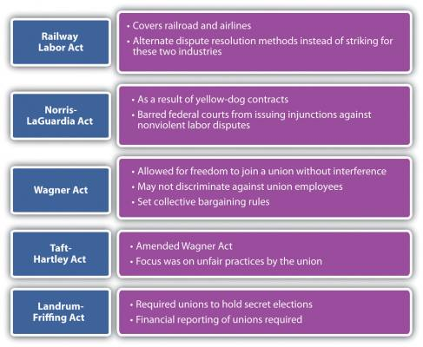
Figure 1. Major Acts Regarding Unions
Learn more about the above Major Acts Regarding Unions.

The Unionization Process
There are two ways in which a unionization process can begin: The union may contact several employees and discuss the possibility of a union, or employees may contact a union on their own. The union will then help employees gather signatures to show that the employees want to be part of a union. To hold an election, the union must show signatures from over 30 percent of the employees of the organization.
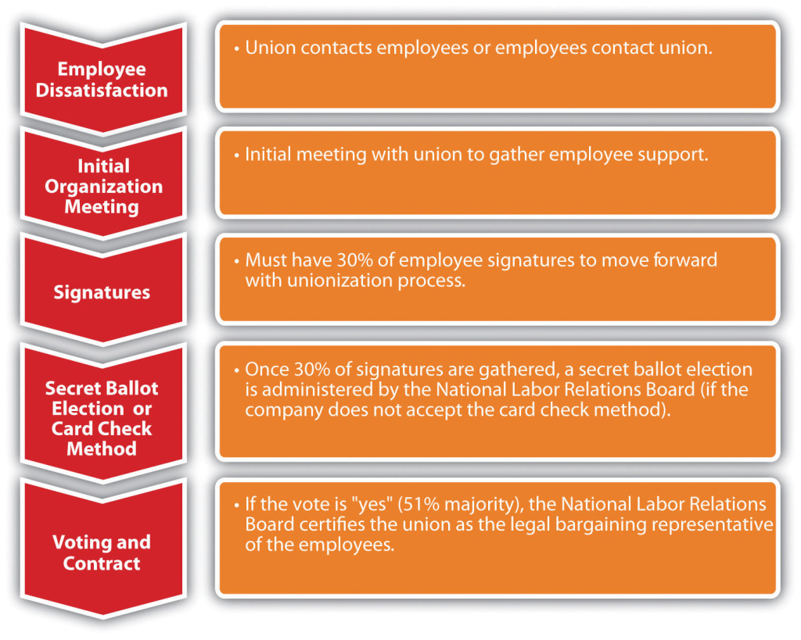
Figure 2. The Unionization Process
Once the signatures are gathered, the National Labor Relations Board is petitioned to move forward with either the card check method or a secret-ballot election.
In the card check method, the union organizer provides the company with authorization cards signed by a simple majority (half plus one). The employer can accept the cards as proof that the employees desire a union in their organization. The NLRB then certifies the union as the employees’ collective bargaining representative.
If the organization does not accept the card check method as authorization for a union, then a secret ballot is held. A petition must be filed by the NLRB, and an election is usually held two months after the petition is filed. In essence, the employees vote whether to unionize or not, and there must be a simple majority (half plus one). The NLRB is responsible for election logistics and counting of ballots. Observers from all parties can be present during the counting of votes. Once votes are counted, a decision on unionization occurs, and if the workers have agreed to join the union, the collective bargaining process begins.
Once the NLRB is involved, there are many limits as to what the employer can say or do during the process to prevent unionization of the organization. It is advisable for HR and management to be educated on what is legal and illegal to say during this process. For example, it is illegal to threaten or intimidate employees if they are discussing a union. You cannot threaten job, pay, or benefits loss as a result of forming a union. Figure 3, “Things That Shouldn’t Be Said to Employees during a Unionization Process,” below includes information on what should legally be avoided if employees are considering unionization.
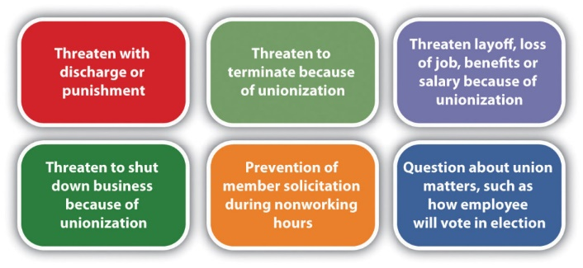
Figure 3. Things That Shouldn’t Be Said to Employees during a Unionization Process
Obviously, it’s in the best interest of the union to have as many members as possible. Because of this, unions may use many tactics during the organizing process. For example, many unions are politically involved and support candidates who they feel best represent labor. They provide training to organizers and sometimes even encourage union supporters to apply for jobs in nonunion environments to actively work to unionize other employees when they are hired. This practice is called union salting. Unions, especially on the national level, can be involved in corporate campaigns that boycott certain products or companies because of their labor practices.

Strategies Companies Use to Avoid Unionization
Most organizations feel the constraints of having a union organization are too great. It affects the cost to the organization and operation efficiency. Collective bargaining at times can put management at odds with its employees and raise the cost of producing products and services. Ideally, companies will provide safe working conditions, fair pay, and benefits so the employees do not feel they need to form a union.
There are three main phases of unionization:
- Phase 1: Your organization is union-free and there is little or no interest in unionizing.
- Phase 2: You learn that some employees are discussing unionization or you learn about specific attempts by the union to recruit employees.
- Phase 3: You receive a petition from the National Labor Relations Board filed by a union requesting a unionization vote.
Because of increased costs and operational efficiency, it is normally in a company’s best interest to avoid unionization. While in Phase 1, it is important to review employee relations programs including pay, benefits, and other compensation. Ensure the compensation plans are fair so employees feel fairly treated and have no reason to seek the representation of a union.
Despite your best efforts, you could hear of unionization in your organization. The goal here is to prevent the union from gaining enough support to petition for a National Labor Relations Board election. Since only 30 percent of employees need to sign union cards for a vote to take place, this phase to avoid unionization is very important. During this time, HR professionals and managers should respond to the issues the employees have and also develop a specific strategy on how to handle the union vote, should it get that far.
In Phase 3, familiarization with all the National Labor Relations Board rules around elections and communications is important. With this information, you can organize meetings to inform managers about these rules. At this time, you will likely want to draw up an anti-union campaign and communicate that to managers, but also make sure it does not violate laws. To this end, develop specific strategies to encourage employees to vote “no” on joining the union. Some of the arguments that might be used include talking with the employee and mentioning the following:
- Union dues are costly.
- Employees could be forced to go on strike.
- Employees and management may no longer be able to discuss matters informally and individually.
- Unionization can create more bureaucracy within the company.
- Individual issues may not be discussed.
- Many decisions within a union, such as vacation time, are based on seniority only.
With unionization in decline, it is likely you may never be involved in a union organizing drive. However, organizations such as Change to Win are trying to increase union membership. Teamsters, United Food and Commercial Workers, United Farm Workers, and Service Employees International Union are all unions affiliated with this organization. The next few years will be telling as to the fate of unions in today’s organizations.
The Process of Collective Bargaining
When employees vote to unionize, the process for collective bargaining begins. Collective bargaining is the process of negotiations between the company and representatives of the union. The goal is for management and the union to reach a contract agreement, which is put into place for a specified period of time. Once this time is up, a new contract is negotiated. In this section, we will discuss the components of the collective bargaining agreement.
In any bargaining agreement, certain management rights are not negotiable, including the right to manage and operate the business, hire, promote, or discharge employees. However, in the negotiated agreement there may be a process outlined by the union for how these processes should work. Management rights also include the ability of the organization to direct the work of the employees and to establish operational policies. As an HR professional sits at the bargaining table, it is important to be strategic in the process and tie the strategic plan with the concessions the organization is willing to make and the concessions the organization will not make.
Another important point in the collective bargaining process is the aspect of union security. Obviously, it is in the union’s best interest to collect dues from members and recruit as many new members as possible. In the contract, a checkoff provision may be negotiated. This provision occurs when the employer, on behalf of the union, automatically deducts dues from union members’ paychecks. This ensures that a steady stream of dues is paid to the union.
To recruit new members, the union may require something called a union shop. A union shop requires a person to join the union within a certain time period of joining the organization. In right-to-work states a union shop may be illegal. Twenty-two states have passed right-to-work laws. These laws prohibit a requirement to join a union or pay dues and fees to a union. To get around these laws, agency shops were created. An agency shop is similar to a union shop in that workers do not have to join the union but still must pay union dues. Agency shop union fees are known as agency fees and may be illegal in right-to-work states.
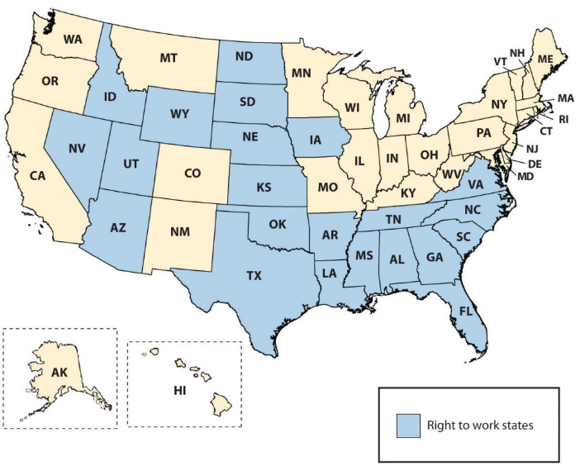
Figure 4. Map of Right-to-Work States
In a collective bargaining process, both parties are legally bound to bargain in good faith. This means they have a mutual obligation to participate actively in the deliberations and indicate a desire to find a basis for agreement. There are three main classifications of bargaining topics: mandatory, permissive, and illegal. Wages, health and safety, management rights, work conditions, and benefits fall into the mandatory category. Permissive topics are those that are not required but may be brought up during the process. An example might include the requirement of drug testing for candidates or the required tools that must be provided to the employee to perform the job, such as a cellular phone or computer. It is important to note that while management is not required by labor laws to bargain on these issues, refusing to do so could affect employee morale. Some bargaining issues are illegal topics, which obviously cannot be discussed. Illegal issues may be of a discriminatory nature or anything that would be considered illegal outside the agreement.
Examples of Bargaining Topics
- Pay rate and structure
- Health benefits
- Incentive programs
- Job classification
- Performance assessment procedure
- Vacation time and sick leave
- Health plans
- Layoff procedures
- Seniority
- Training process
- Severance pay
- Tools provided to employees
- Process for new applicants
Steps in Collective Bargaining
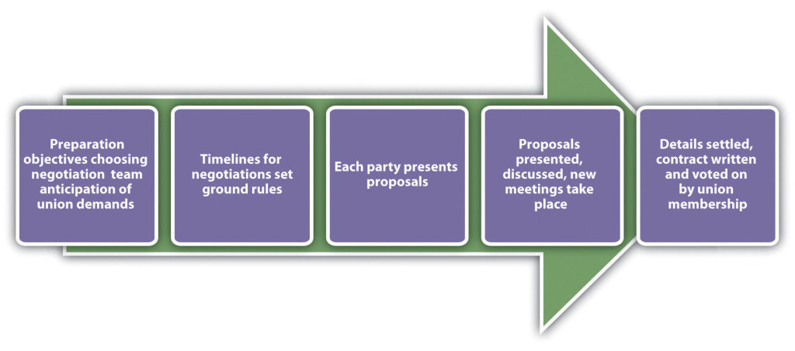
Figure 5. Steps in Collective Bargaining
The collective bargaining process has five main steps. The first step is the preparation of both parties. The negotiation team should consist of individuals with a) knowledge of the organization and b) the skills to be an effective negotiator. An understanding of the working conditions and the dissatisfaction with them is an important part of this preparation step. Establishing objectives for the negotiation and reviewing the old contract are key components to this step. The management team should also prepare for and anticipate union demands, to better prepare for offering compromises.
The second step of the process involves both parties agreeing on how the timelines will be set for the negotiations. In addition, setting ground rules for how the negotiation will occur is an important step, as it lays the foundation for the work to come.
In the third step, each party comes to the table with proposals. They will likely involve initial opening statements and options to resolve any existing situations. The key to a successful proposal is to come to the table with a “let’s make this work” attitude. An initial discussion takes place and then each party generally goes back to determine which requests it can honor and which it can’t.
In step 4, more meetings are generally set up to continue further discussion and negotiation. This step may take many months and proposals.
The fifth step occurs when the group comes to an agreement or settlement. A new contract is written and the union members vote on whether to accept the agreement. If the union doesn’t agree, then the process begins all over again.
Ramifications of a Bargaining Impasse
When the two parties are unable to reach consensus on the collective bargaining agreement, this is called a bargaining impasse. A bargaining impasse could mean the union goes on strike, or management resorts to a lockout.
Various kinds of strikes are used to show the displeasure of workers regarding a bargaining impasse. Generally, the goal of a strike is to put pressure on the organization to accept the proposed contract. But there are many kinds of strikes. For example, an economic strike is a strike stemming from unhappiness about the economic conditions during contract negotiations. An unfair labor practices strike can happen during negotiations to try to get the organization to cease committing what the union believes to be an unfair labor practice. Jurisdictional strikes are used to put pressure on an employer to assign work to members of one union versus another (if there are two unions within the same organization) or to put pressure on management to recognize one union representation when it currently recognizes another. Sympathy strikes are work stoppages by other unions designed to show support for the union on strike. While they are not illegal, they may violate the terms of the collective bargaining agreement.
A sick-out is when members of a union call in sick, which may be illegal since they are using allotted time. The goal of a sick-out strike is to show the organization how unproductive the company would be if the workers did go on strike. A walk-out is an unannounced refusal to perform work. However, this type of tactic may be illegal if the conduct is irresponsible or indefensible.
Management may use a lockout—which prevents workers from working—to put pressure on the union to accept the contract. A lockout can only be legally conducted when the existing collective bargaining agreement has expired and there is truly an impasse in contract negotiations.
Some organizations will impose a lockout if workers engage in slowdowns, an intentional reduction in productivity. Some unions will engage in a slowdown instead of a strike, because the workers still earn pay, while in a strike they do not.

Employee Rights: Job Protection and Privacy
Employee rights are defined as the requirement to receive fair treatment from employers. This section will discuss employee rights surrounding job protection and privacy.
If HR doesn’t understand or properly manage employee rights, lawsuits are sure to follow. It’s the HR professional’s job to understand and protect the rights of employees. In the United States, the employment-at-will principle is the right of an employer to fire an employee or an employee to leave an organization at any time, without any specific cause. This principle gives both the employee and employer freedom to terminate the relationship at any time. There are three main exceptions to this principle, and whether they are accepted is up to the various states:
- Public policy exception. With a public policy exception, an employer may not fire an employee if it would violate the individual state’s doctrine or statute. For example, in Borse v. Piece Goods Shop in Pennsylvania, a federal circuit court of appeals ruled that Pennsylvania law may protect at-will employees from being fired for refusing to take part in drug test programs if the employee’s privacy is invaded. Borse contended that the free speech provisions of the state and of the First Amendment protected the refusal to participate. Some public policy exceptions occur when an employee is fired for refusing to violate state or federal law.
- Implied contract exception. In a breach of an implied contract, the discharged employee can prove that the employer indicated that the employee has job security. The indication does not need to be formally written, only implied. In Wright v. Honda, an Ohio employee was terminated but argued that the implied contract exception was relevant to the employment-at-will doctrine. She was able to prove that in orientation, Honda stressed to employees the importance of attendance and quality work. She was also able to prove that the language in the associate handbook implied job security: “the job security of each employee depends upon doing your best on your job with the spirit of cooperation.” Progress reports showing professional development further solidified her case, as she had an implied contract that Honda had altered the employment-at-will doctrine through its policies and actions.
- Good faith and fair dealing exception. In the good faith and fair dealing exception, the discharged employee contends that he was not treated fairly. This exception to the employment-at-will doctrine is less common than the first two. Examples might include firing or transferring of employees to prevent them from collecting commissions, misleading employees about promotions and pay increases, and taking extreme actions that would force the employee to quit.
View the table, Acceptance of Employment-at-Will Exceptions, State-by-State
When one of the exceptions can be proven, wrongful discharge accusations may occur. The United States is one of the few major industrial powers that utilizes an employment-at-will philosophy. Most countries, including France and the UK, require employers to show just cause for termination of a person’s employment. The advantage of employment at will allows for freedom of employment; the possibility of wrongful discharge tells us that we must be prepared to defend the decision to terminate an employee so as to not be charged in a wrongful discharge case.
Employees also have job protection if they engage in whistle blowing. Whistle blowing refers to an employee’s telling the public about ethical or legal violations of his or her organization. This protection was granted in 1989 and extended through the Sarbanes-Oxley Act of 2002. Many organizations create whistle-blowing policies and a mechanism to report illegal or unethical practices within the organization.
Another consideration for employee job protection is that of an implied contract. It is in the best interest of HR professionals and managers alike to avoid implying an employee has a contract with the organization. In fact, many organizations develop employment-at-will policies and ask their employees to sign these policies as a disclaimer for the organization.
A constructive discharge means the employee resigned, but only because the work conditions were so intolerable that he or she had no choice. For example, if James is being sexually harassed at work, and it is so bad he quits, he would need to prove not only the sexual harassment but that it was so bad it required him to quit. This type of situation is important to note; should James’s case go to court and sexual harassment and constructive discharge are found, James may be entitled to back pay and other compensation.
The Worker Adjustment and Retraining Notification Act (WARN) requires organizations with more than one hundred employees to give employees and their communities at least 60 days’ notice of closure or layoff affecting 50 or more full-time employees. This law does not apply in the case of unforeseeable business circumstances. If an employer violates this law, it can be subject to owing back pay to employees. This does not include workers who have been with the organization for less than six months, however.
Retaliatory discharge means punishment of an employee for engaging in a protected activity, such as filing a discrimination charge or opposing illegal employer practices. For example, it might include poor treatment of an employee because he or she filed a workers’ compensation claim. Employees should not be harassed or mistreated should they file a claim against the organization.
Privacy Rights
Technology makes it possible to more easily monitor aspects of employees’ jobs, although a policy on this subject should be considered before implementing it. There is a question about whether an employer should be allowed to monitor an employee’s online activities. This may include work e-mail, websites visited using company property, and personal activity online.
Digital Footprints, Inc. is a company that specializes in tracking the digital movements of employees and can provide reports to the organization by tracking these footprints. This type of technology might look for patterns, word usage, and other communication patterns between individuals. This monitoring can be useful in determining violations of workplace policies, such as sexual harassment. This type of software and management can be expensive and it is imperative to address its value in the workplace.
Another privacy concern is monitoring employee postings on external websites. Companies such as Social Sentry can be contracted to monitor employee postings on sites such as Facebook, Twitter, LinkedIn, and YouTube. Lawyers warn, however, that this type of monitoring should only be done if the employee has consented. A monitoring company isn’t always needed to monitor employees’ movements on social networking. And sometimes employees don’t even have to tweet something negative about their own company to lose their job.
The US Patriot Act also includes caveats to privacy when investigating possible terrorist activity. The Patriot Act requires organizations to provide private employee information when requested. Overall, it is a good idea to have a clear company policy and perhaps even a signed waiver from employees stating they understand their activities may be monitored and information shared with the U.S. government under the Patriot Act.
Depending on the state in which you live, employees may have rights to view their personnel files and correct false information within their files. Medical or disability information should be kept separate from the employee’s work file, per the Americans with Disabilities Act. In addition, the Health Insurance Portability and Accountability Act (HIPAA) mandates that health information should be private, and therefore it is good practice to keep health information in a separate file as well.
Finally, drug testing and the right to privacy is a delicate balancing act. Organizations that implement drug testing often do so for insurance or safety reasons. The ADA does not view testing for illegal drug use as a medical examination (making such testing legal), and people using illegal drugs are not protected under the ADA. However, people covered under ADA laws are allowed to take medications directly related to their disability.
In organizations where heavy machinery is operated, a monthly drug test may be a job requirement. In fact, under the Omnibus Transportation Employee Testing Act of 1991, employers are legally required to test for drugs in transportation-related businesses such as airlines, railroads, trucking, and public transportation, such as bus systems. Medical marijuana is a relatively new issue that is still being addressed in states that allow its use. For example, if the company requires a drug test and the employee shows positive for marijuana use, does asking the employee to prove it is being used for medical purposes violate HIPAA privacy laws? This issue is certainly one to watch over the coming years.
Source: Beginning Management of Human Resources. Located at: lardbucket.org. License: CC BY-NC-SA.
Module 4 Summary
In this final module, we examined labor and employee relations and concluded with a brief perspective on how ethical concerns pervade all aspects of human resource management. Most employers want to create work environments that are attractive to potential and current employees. At times, however, the relationship between employer and employee can be a bit tricky. Sometimes, there are significant differences between what the employer needs/wants and what the employee needs/wants. In these situations, as we have seen, employees might turn to labor unions for help.

